1. The 2026 SSRAC meeting for review of proposed FY29 NAVSEA Standard Items will be held from 22-26 JUNE 2026, at the Virginia Advanced Shipbuilding and Carrier Integration Center (VASCIC, 2401 West Avenue, Newport News, VA, 23607).

2. Milestone dates for the meeting are as follows:
a. 22 April 2026: Cutoff date for attendee registration.
b. 13 May 2026: Cutoff date for submission of Change Proposals to the SSRAC Coordinator.
c. 22 May 2026: SSRAC Coordinator to provide serialized copy of Change Proposals to each subcommittee
d. 22 June 2026: Convene SSRAC meeting. All VASCIC rooms are available for Subcommittee work.
e. 23 June 2026: Convene SSRAC meeting. (General Assembly) This is the first full day for all attendees (In brief is scheduled for 0800).

3. Each participating activity (e.g., SWRMC, PSNS-IMF, NAVSEA 04, SUPSHIP Bath, Norfolk Naval Shipyard, VSRA, AMMA, SCA) is limited to 2 attendees per subcommittee. Industry representatives are encouraged to participate and provide advice but will not be allowed to participate in any decision making.

4. There will be more information to follow concerning catering / cafe services. No conference fee will be charged.

5. Attendees must be trade oriented and familiar with the SSRAC Program and objectives. Designated representatives should submit a registration form, using the attached Registration Request Form Link. Forms are also available on the SSRAC website at:
http://www.navsea.navy.mil/Home/RMC/CNRMC/OurPrograms/SSRAC.aspx
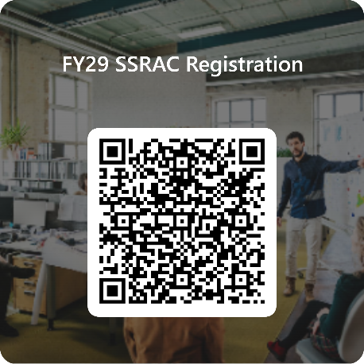
Click on the link or use the QR code:
https://forms.osi.apps.mil/r/kR94FwDJpZ

REGISTRATION REQUESTS WILL NOT BE ACCEPTED AFTER 22 APRIL 2026

REGISTRATION REQUESTS MUST BE SUBMITTED USING THE PRESCRIBED LINK.

REGISTRATION REQUESTS MUST HAVE ACTIVITY AND/OR ORGANIZATION/COMPANY FILLED OUT.

6. Submission of Change Proposals: CHANGE PROPOSAL REQUESTS MUST BE SUBMITTED USING THE PRESCRIBED FORM ATTACHED (Form has been Updated)

a. Change Proposal Forms are available on the SSRAC website at: http://www.navsea.navy.mil/Home/RMC/CNRMC/OurPrograms/SSRAC.aspx

RMCs submitting Change proposal please submit through your local RMC SSRAC Coordinator.

b. Please be sure to indicate whether the proposal is "Administrative" or "Technical" in nature, and whether there is a cost or schedule impact. Incomplete forms will be returned.

c. Submissions should be e-mailed to SSRAC@us.navy.mil . The SSRAC Coordinator will act on minor administrative changes, but all "major" proposals will be assigned a SSRAC Number and will be referred to the appropriate subcommittee for action.

CHANGE PROPOSALS WILL NOT BE ACCEPTED AFTER THE 13 MAY 2026 MILESTONE FOR PROPOSAL SUBMISSION.

7. The subcommittees review proposals on issues relating to their technical/trade specialties and provide recommendations to the Steering Committee with supporting rationale. The Steering Committee acts on the recommendations of the subcommittees and handles issues that either cannot be resolved by the subcommittee or are beyond the scope of any one subcommittee.

a. The subcommittees of the SSRAC are:

-Environmental/Safety/Health
-Hull/Preservation
-Machinery/QA
-Piping/Boiler
-Electrical/Electronics
-4-E/Phraseology
-General (non-trade-specific issues)

Respectfully,
James A. Simmons
Technical Director
CNRMC Code 200
James.A.Simmons166.civ@us.navy.mil
(757) 400-0020

